FACULDADE SENAC GOIÁS

LUCAS DE ALMEIDA BORGES - ADS 4

Documentação:

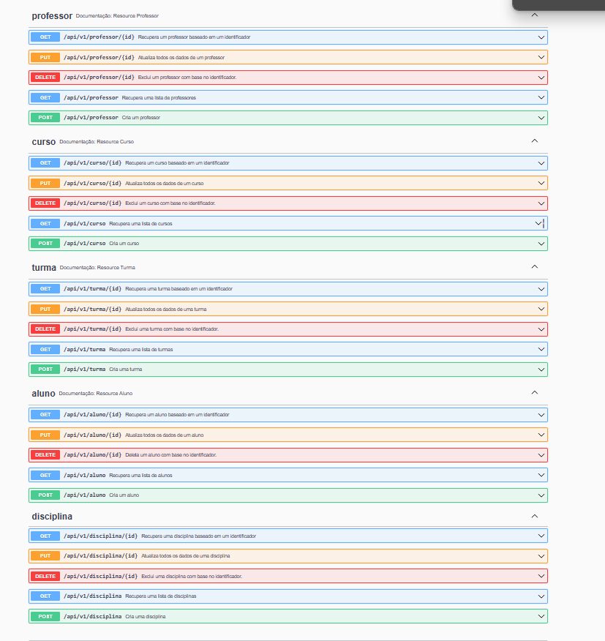

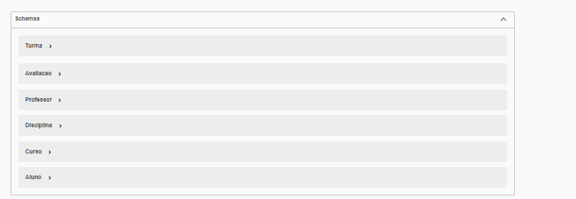

PROFESSOR

|  |  |  |  |
| --- | --- | --- | --- |
| POST | GET | DELETE | PUT |
|  |  |  |  |

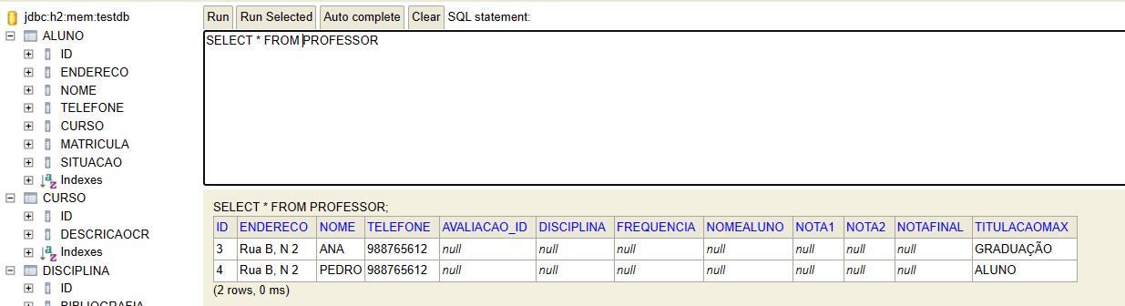

ALUNO

|  |  |  |  |
| --- | --- | --- | --- |
| POST | GET | DELETE | PUT |
|  |  |  |  |

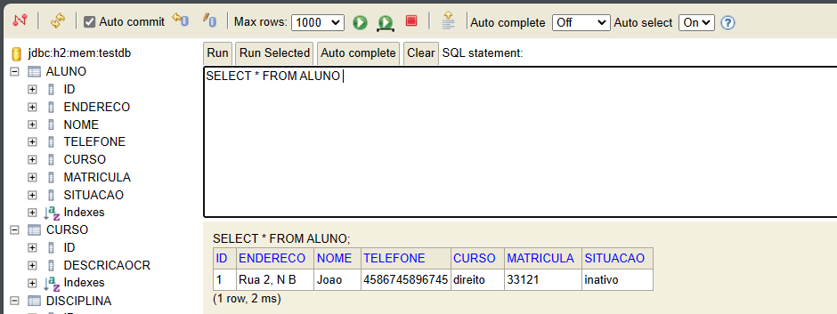

|  |  |  |
| --- | --- | --- |
| CURSO | DISCIPLINA | TURMA |
|  |  |  |

CURSO

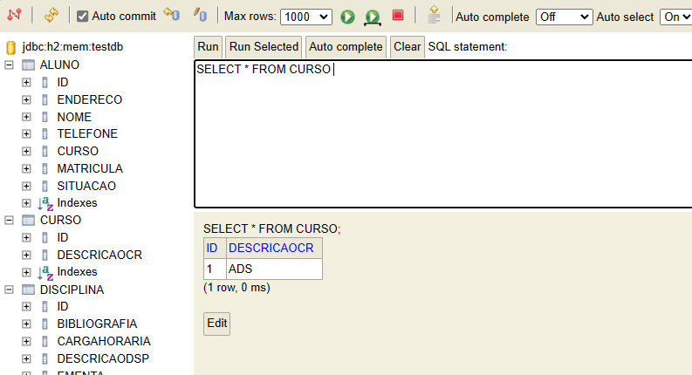

DISCIPLINA

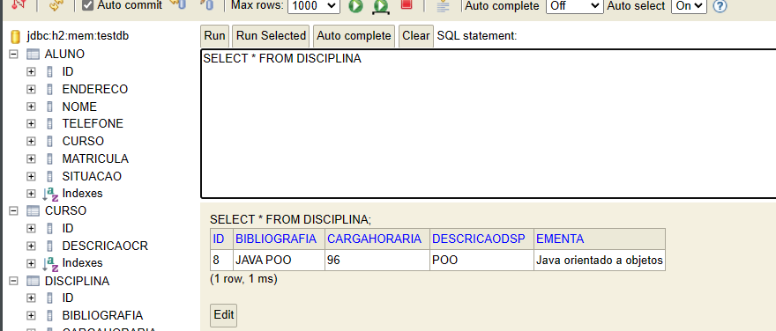

TURMA

